Lab 5. [Dynamically add a person’s manager as an approver (Approval Part 2)](https://preview.flow.microsoft.com/en-us/galleries/public/templates/7b4b0defab8145578a67108723b38095/get-my-manager-to-approve-a-travel-request/)

**Author:** Serge Luca aka “Doctor Flow”

**Duration:** 15 minutes.

**Scenario:** In this lab, we will explore how a Flow can dynamically assign an approval task to the current user’s manager

**Prerequisites**: The lab Approval (part 1) must be completed.

Tasks:

1. Go back to the previous expense approval Flow, edit the Flow, and add a **Get manager (V2)** action just after the **Update item** action:

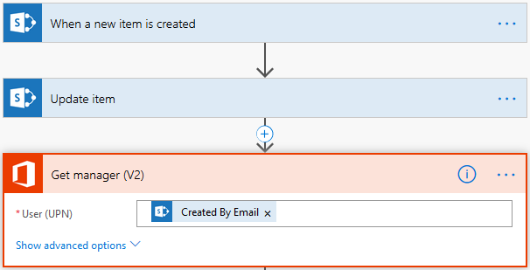

1. Set the **User (UPN)** to the **Created By Email** dynamic property of the **When a new item is created** action.

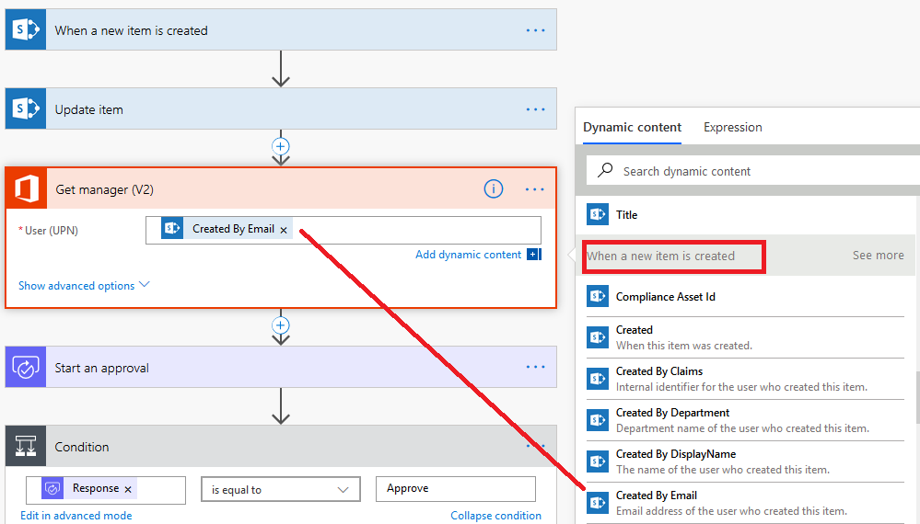

1. Update the **Start an approval** action **Assigned To** property with the **Mail** dynamic property of the **Get manager (V2)** action.

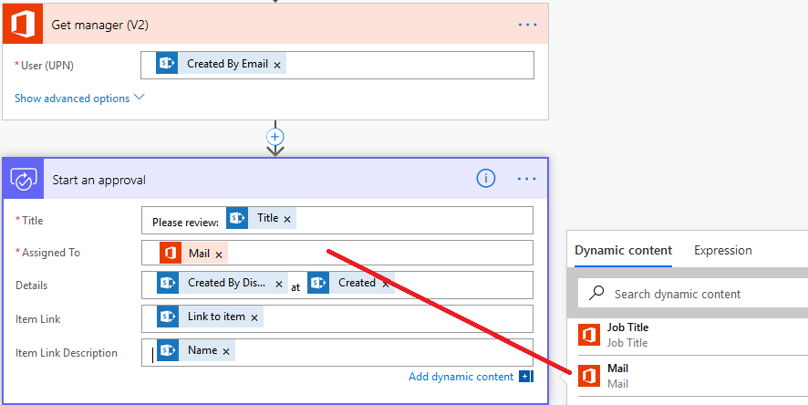

**Note:** Ensure the current user has a manager defined in Azure Active directory.

1. Save and test the Flow.
2. In order to approve the request, log in to Microsoft Flow with the manager account to approve/reject your request from the Microsoft Flow approval center.

**We need your feedback**

Do you want to report an issue or to suggest something? We need your feedback: <https://github.com/Power-Automate-in-a-day/Training-by-the-community/issues>